

A 2016 article and some personal comments from 2 years ago
about elflocks

Why it’s not OK for white people to have dreadlocks
No, you can’t use the Celts as an excuse

You’ve probably seen the video of a black woman “assaulting” a white student over his dreadlocks
in San Francisco. No doubt you’ve seen Justin Bieber’s unfortunate blonde dreadlocks in recent days. There seems to be confusion about why people are angry. Let me explain why.
In this article, a black man will tell you why white people should not have dreadlocks. This is by no means intended to oppress any white people who reassure me they have Jamaican friends and are avid drinkers of Red Stripe so having dreadlocks surely doesn’t make them an appropriator of black culture.
Having dreadlocks doesn’t mean you are a racist person and sure, you may not have meant to piss people off – but that doesn’t mean that dreadlocks on white people exist in an anti-race vacuum.
Sure, dreadlocks have appeared at different unconnected parts of the world over time – so you may attribute it to Egyptians or Celtic “fairie locks”.
But really, the source of its current popularity is largely due to the life and death of Marley and the apparent “humanist” movement
he created (NB humanism sort of preaches “we’re all humans”, so sees things such as anti-racism and feminism as holding us back). For some it may even be an appreciation of the Rastafari movement.
1
Now, I don’t know why white people choose to wear dreadlocks, but there seem to be a few reasons. If you wear them as an appreciation of black culture, then by wearing dreadlocks and perpetuating white privilege as a result then aren’t you actually harming the black diaspora in the UK? If you truly cared for black people and not just our culture you wouldn’t want to wear dreadlocks.
Secondly, if you wear dreadlocks because it “looks cool” then you’re still perpetuating white privilege and you’ve chosen to be ignorant of the significant contemporary history.
Finally, if you wear them because you think it symbolises a humanist ideal, then you’ve attached the wrong political meaning to them and instead you’re damaging the anti-oppression movement for which they truly symbolise.
Those are just three reasons I can think of for a why a white person would wear them. Each reason to wear it has its own significance and each one shows appropriation: either by utilising black culture without care for black people, utilising black culture without caring for black history, or utilising black culture yet attributing your own meaning to it (even though it’s both incorrect and damaging).
Unless you want to wear them because your great25 grandfather was a Celt with fairie locks and you want to be just like him, you’re likely wearing it because it looks cool or you think you’re a woke humanist.
Either way it lacks appreciation for the oppression of black people in the UK, the US, and across the globe.
Even then, fairie locks aren’t even really dreadlocks. It’s just tangled hair. It’s called fairie locks cos they say a fairy tangled your hair in your sleep – it’s not conscious and not all Celts even deemed it attractive so it doesn’t stand as an argument about cultural sources of dreadlocks.
If you’re wearing them and don’t believe in white privilege and are not doing anything to make yourself an ally to black liberation then it’s appropriation.
2

If you’re wearing dreadlocks and don’t understand that you’ll be seen as ‪#‎edgyleeds or ‪#‎staywoke whereas a black person wearing it will be asked where to buy weed or why their hair so dirty, then its appropriation and white privilege.
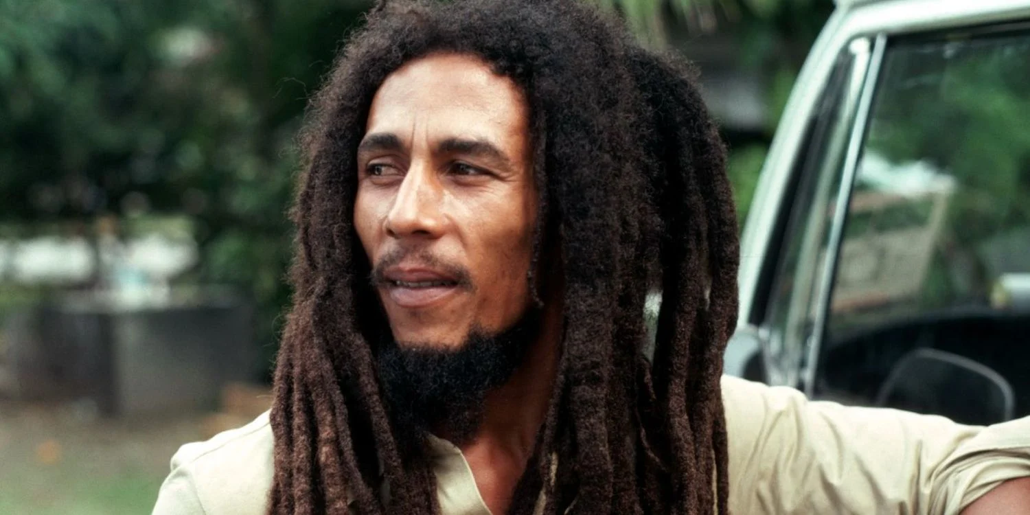

Dreadlocks are most commonly associated with Bob Marley and the Rastafari movement
I believe in equality and I am an advocate for it. I would love to be able to say “we can all share everything” as if we are equals, but we are not.
Appropriating black culture and perpetuating privilege will not get us there. After all, neither Marley nor any Rastafarian would agree with the political (or rather, apolitical) outlooks of many white people with dreadlocks I’ve met.
The intrinsic politics in dreadlocks is that it is a symbol of global anti-racism – which is why it’s a fallacy to use something held dearly to the black liberation movement to perpetuate white privilege.
Source:
https://thetab.com/2016/04/05/dreadlocks-white-people-83996
I kinda feel like a saviour by sprading this but when I nmagine people pretending to be needing crutches because it makes them look mellow that would defenitely make me not want to interact with this group, so I imagine this is one of the reasons Dutch activism is so white. This is what someone else wanted to add:

I believe in equality and I am an advocate for it. 1 would love to be able to say "we can all share everything" as it we are equals, but we are not. Appropriating black culture and perpetuating privilege will not get us there.
3
After all, neither Marley nor any Rastafarian would agree with the political (or rather, apolitical) outlooks of many white people with dreadlocks I've met. The intrinsic politics in dreadlocks is that it is a symbol of global anti-racists -which is why its a fallacy to use something held dearly to the black liberation movement to perpetuate white privilege.
6
------------ ------------------------ --------------
Editors/compilers of this zines/ notes:
The Rastafari movement (which is really the reason for the popularity of dreadlocks in the West, whether this is consciously realized by the person wearing them or not) was founded around an anti-imperialist/anti-racist cause-- of black people in Jamaica
under the legacy of British colonialism. Despite other problematic (if we are to judge) in the Rastafari movement, of patriarchy and so on, it can't be denied that dreadlocks, or matted hair, originates from this movement of anti-imperialism and anti-racism (which are intertwined, if we can make a pun). Dreads were not only a natural 'non-interference' mode of spirituality, but were a refusal towards western styles, and were politicized within this context of anti-imperialism/racism.
7
We hardly, if ever, see dreadlocks worn by white people for those reasons of anti-imperalism or anti-racism. (Because we hardly ever see white people with dreadlocks leading the fight against racism or colonialism.) Which is to disassociate, knowingly (as an aggressive act of erasure and dismissal-- which says that those issues are not or less important because they don't affect you or you don't see the value in them and don't care to know why it is of value to other people) or unknowingly (as an act of erasure and dismissal that says its not important or relevant for you to even think about what dreadlocks mean, con-temporarily).
And even if so, if white people did wear dreadlocks in the fight against racism, in solidarity, its still not the same. The experience of wearing dreads as a black person is not the same as the experience of wearing dreads as a white person. And that matters. Especially in light of the contemporary context of their 20th century revival. Its not about the Vikings, don't avoid the issue.
8
Additionally, we hear such things as: I've never had a problem with accusations of cultural appropriation. So until a black person approaches me with some valid points as to why I'm being insensitive, I'll keep them" Really? So you know its probably offending some people, but instead of taking some effort of your own you're ping to wait until a Black person feels the need to confront you? Who are you valuing in this situation? It sounds like it's you valuing you, and that's it.
4
The thing is, we feel the need to be harsh because we know what kind of views a lot of you are hiding behind those dreads, and its not really a love and appreciation for black culture.
Its really just basic opportunism, and you want to turn a blind eye to context and the asymetricalities of being white in the world, because having to face up to that makes you uncomfortable. Well we are here to make you uncomfortable. Because lets be honest, everyone outside your bubble thinks its trash what you're doing, and doesn't want to come near you or any of the things you organize because white folks with dreadlocks are a basic red flag. We're not joking, you don't have a good reputation, all of Rotterdam knows what you're doing, and they don't care for it. And no, we aren't judging you because you are a leftist, dirty hippie (be as dirty and left as you want-- if left still means anti-racist), we are judging you because its racially cringy, to say the least, and we don't want to be around it. Cut off the dreads (and think about some things, if you gotta do that) and lets be friends.

And another 2015 article
https://everydayfeminism.com/2015/08/white-feminist-with-dreadlocks/
fairy-locks (or elflocks) are the result of fairies tangling and knotting the hairs of sleeping children and the manes of beasts as the fairies play in and out of their hair at night.
I hope you can rethink why you got this hairstyle and decide to change it at least once per year.
There are so many options in colour and cutting styles

this zine can be found on
http://fakkelplemp.nl/zine/

please send an email with your favorite zines to
info@fakkelplemp.nl
so we can make a subsection with your zines, Mad Pride alseady has a subsection

5

